- Once logged into the Clerk Connect portal, you should be at the “My Subscriptions” page
- Click the “See More Subscription Options button at the bottom of the My Subscriptions page
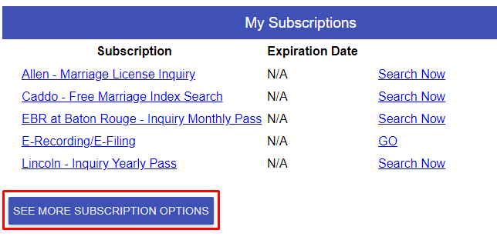

- Opens the “Select a Parish” dropdown Select the Parish you wish to purchase a subscription for
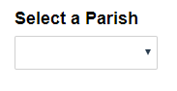

- Select a subscription NOTE: These may vary by parish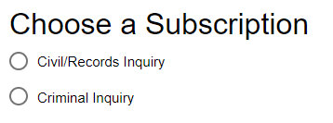

- Select your Subscription option (Daily/Monthly/Yearly) and add an optional pre-pay amount to your account and click the BUY button located at the bottom left
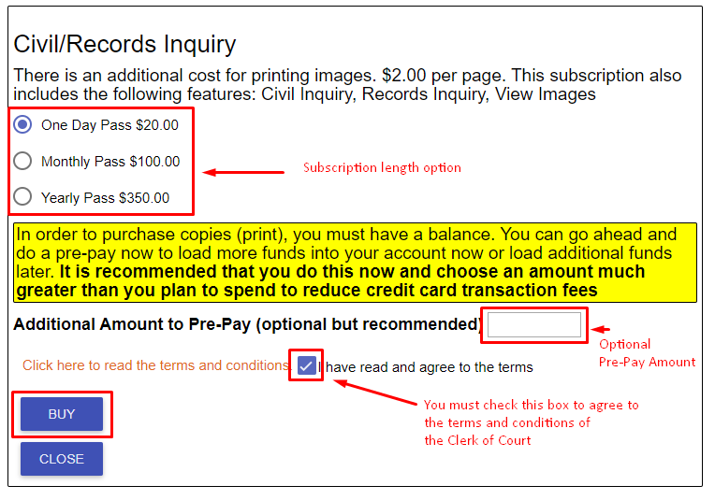

- Confirm your Subscription option selected to purchase as well as any pre-pay amount totals are correct. If everything is correct, click the YES button. If you need to make changes to your purchase, like a different Subscription level or pre-pay amount, click NO
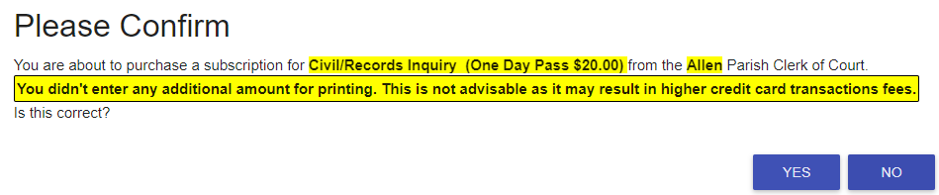
- If you have a credit card or multiple cards saved, you will see the below screen. You may select to use a specific card listed or to use a different card not saved. If using a saved card you will see the below screen. If you choose to use a different card not saved, you will be taken to a payment screen allowing you to enter your card and other related information
